Final Internship Report: Development and Testing of a Custom NIDS Ruleset
Author: Venkata subhash mani
Project: Network Intrusion Detection System (NIDS) Rule Creation and Testing Lab

1.0 Executive Summary
This report documents the successful completion of a four-week project to design, implement, and test a custom ruleset for a Network Intrusion Detection System. A virtualized security lab was constructed to simulate a real-world network environment. Using the Suricata NIDS engine, a series of custom rules were developed to detect various stages of a cyber-attack, including network reconnaissance, application-level brute-force attempts, and simulated malware command-and-control (C2) traffic. All detection rules were systematically verified using industry-standard attack simulation tools. The project successfully demonstrates the core principles of signature-based threat detection and provides a foundational ruleset for identifying common network threats.

2.0 Lab Environment & Methodology

2.1 Lab Topology
A secure, isolated virtual lab was created using VMware Workstation to ensure all simulated attacks were safely contained.
- NIDS/Attacker Platform: A Kali Linux VM (192.168.70.10) hosting the Suricata NIDS engine and all attack tools (Nmap, Hydra).
- Victim Machine: A Windows 10 VM (192.168.70.20) hosting the target services (SSH, FTP).
- Network: A private Host-Only network (192.168.70.0/24) was configured to connect the two VMs without external internet access.

2.2 Tools & Technologies
- NIDS Engine: Suricata
- Virtualization: VMware Workstation
- Operating Systems: Kali Linux, Windows 10
- Attack & Testing Tools: Nmap, Hydra, Python, PowerShell

2.3 Methodology
Each phase of the project followed a consistent and reproducible methodology:
- Setup: A vulnerable service was enabled on the victim machine.
- Rule Development: A custom Suricata rule was written to detect a specific attack signature.
- Attack Simulation: An attack was launched from the Kali VM against the Windows VM.
- Verification: The Suricata log file (/var/log/suricata/eve.json) was analyzed to confirm the generation of the correct alert.

3.0 Week 1: Lab Setup and Baseline Verification
The initial phase focused on building the lab and confirming the NIDS was operational. After installing and configuring Suricata, a baseline test was performed using a simple ICMP (ping) rule.
- Rule: alert icmp any any -> any any (msg:"ICMP Ping Detected"; sid:1000001; rev:1;)
- Test: A ping was sent from the Windows VM to the Kali VM.
- Result: The NIDS successfully generated the "ICMP Ping Detected" alert, confirming the lab was fully functional.
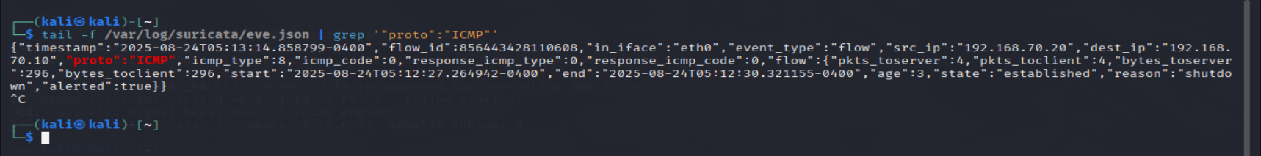

4.0 Week 2: Detection of Network Reconnaissance
This phase focused on writing rules to detect stealthy network scans launched with Nmap. Four common scan types were targeted.

4.1 TCP SYN Scan (Stealth Scan)
- Rule: alert tcp any any -> $HOME_NET any (msg:"NMAP TCP SYN Scan Detected"; flags:S,12; sid:1000002; rev:1;)
- Attack: sudo nmap -sS -Pn 192.168.70.20
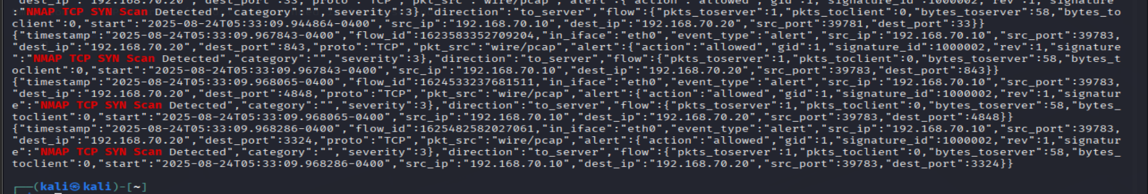

4.2 TCP FIN Scan
- Rule: alert tcp any any -> $HOME_NET any (msg:"NMAP FIN Scan Detected"; flags:F,12; sid:1000003; rev:1;)
- Attack: sudo nmap -sF -Pn 192.168.70.20
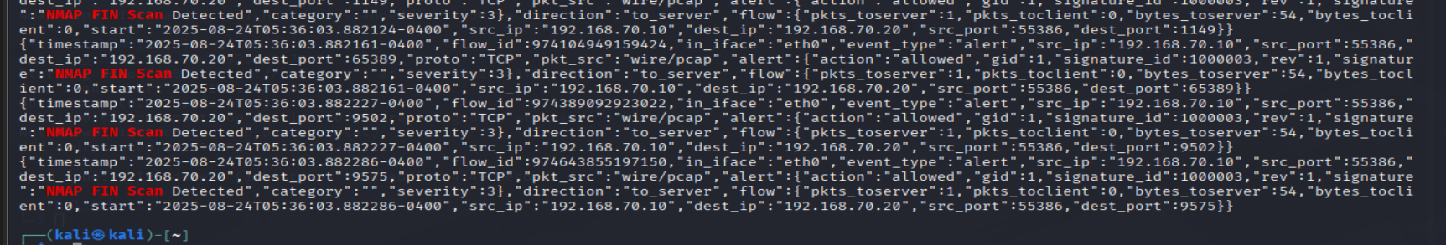

4.3 TCP Xmas Scan
- Rule: alert tcp any any -> $HOME_NET any (msg:"NMAP Xmas Scan Detected"; flags:FPU,12; sid:1000004; rev:1;)
- Attack: sudo nmap -sX -Pn 192.168.70.20
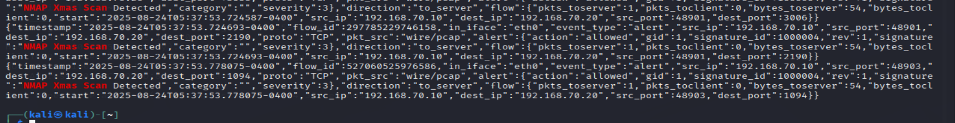

4.4 TCP Null Scan
- Rule: alert tcp any any -> $HOME_NET any (msg:"NMAP Null Scan Detected"; flags:0; sid:1000005; rev:1;)
- Attack: sudo nmap -sN -Pn 192.168.70.20
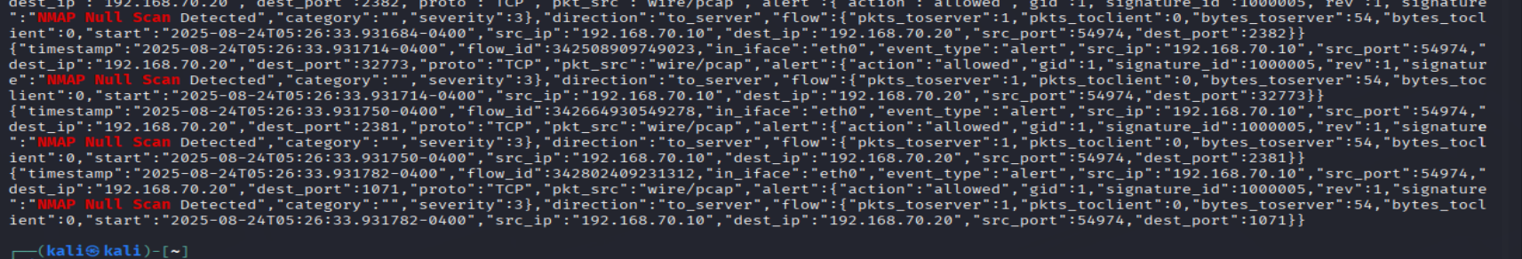

5.0 Week 3: Detection of Application-Level Attacks
This phase moved up the network stack to detect brute-force attacks against common services using Hydra.

5.1 SSH Brute-Force Detection
- Strategy: As SSH traffic is encrypted, a rate-based rule was created to detect the behaviour of a brute-force attack (many rapid connection attempts from one source).
- Rule: alert tcp any any -> $HOME_NET 22 (msg:"SSH Brute-Force Attempt Detected"; flow:to_server,established; detection_filter:track by_src, count 5, seconds 60; sid:1000006; rev:1;)
- Attack: hydra -l admin -P passwords.txt ssh://192.168.70.20
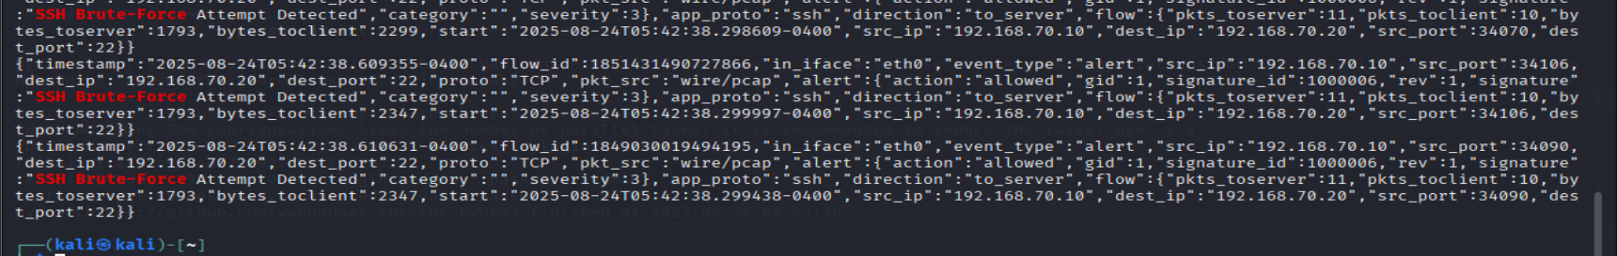

5.2 FTP Brute-Force Detection
- Strategy: As FTP traffic is unencrypted, a content-based rule was created to inspect the packet data for the attacker's USER command, which signifies a login attempt.
- Rule: alert tcp any any -> $HOME_NET 21 (msg:"FTP Brute-Force Attempt (Login Failed)"; flow:to_server,established; content:"USER"; sid:1000008; rev:1;)
- Attack: hydra -l admin -P badpasswords.txt ftp://192.168.70.20
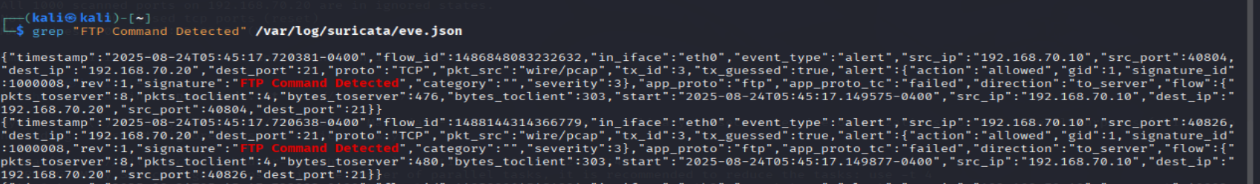

6.0 Week 4: Detection of Malware C2 Beaconing
The final phase focused on detecting a simulated malware beacon disguised as normal web traffic.
- Strategy: A rule was written to inspect the User-Agent field of HTTP requests for a custom, non-standard string that would indicate a malicious client rather than a real web browser.
- Rule: alert http any any -> $HOME_NET 80 (msg:"Malware C2 Beacon Detected (Suspicious User-Agent)"; flow:to_server; http.user_agent; content:"C2-Beacon-Client"; sid:1000009; rev:1;)
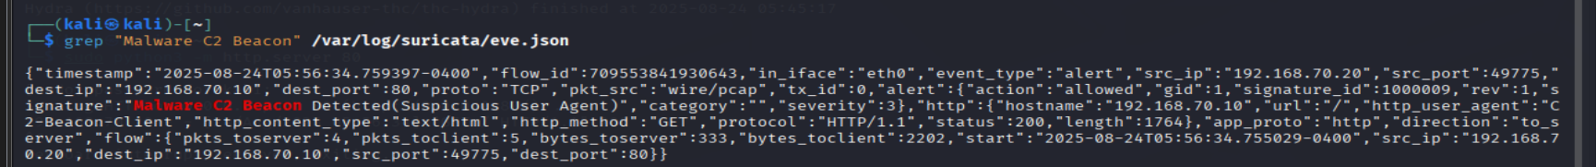
- Attack: A custom web request was sent from the Windows victim using PowerShell:
Invoke-WebRequest -Uri http://192.168.70.10 -Headers @{ "User-Agent" = "C2-Beacon-Client" }

7.0 Conclusion & Key Learnings
This project successfully demonstrated the end-to-end process of developing a custom NIDS ruleset. A stable virtual lab was constructed, and a series of increasingly sophisticated rules were written and verified. The key learnings from this internship project include:
- Behavioral vs. Content Analysis: The ability to choose the correct detection strategy based on the protocol (e.g., rate-based for encrypted SSH vs. content-based for unencrypted FTP).
- Protocol-Aware Rule Writing: The use of Suricata's advanced protocol parsers (like http.user_agent) to create highly efficient and precise rules.
- Systematic Troubleshooting: The importance of using tools like tcpdump to analyze raw traffic and refine rules when initial tests fail.
- Version Control for Security: The use of Git and a structured repository to manage rules, documentation, and attack plans in a collaborative environment.
The final ruleset provides a solid foundation for detecting a range of common threats and serves as a successful proof-of-concept for the project's objectives.

